Writing a good paragraph is like following the road rules!
TRAFFIC LIGHT
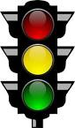
T = Green = go/start → Topic sentence
Yellow = slow down
E→ Explain your topic further
E→ Provide evidence or examples to support your topic
E→ Elaborate on your evidence and examples.
L = red = stop → Linking or concluding sentence

